Chapter 3, Problem 35.

Rework Prob. 3.5 using mesh analysis.

Chapter 3, Problem 5

Obtain v₀ in the circuit of Fig. 3.54.

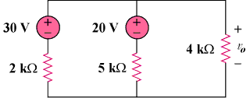

Figure 3.54
For Prob. 3.35.

